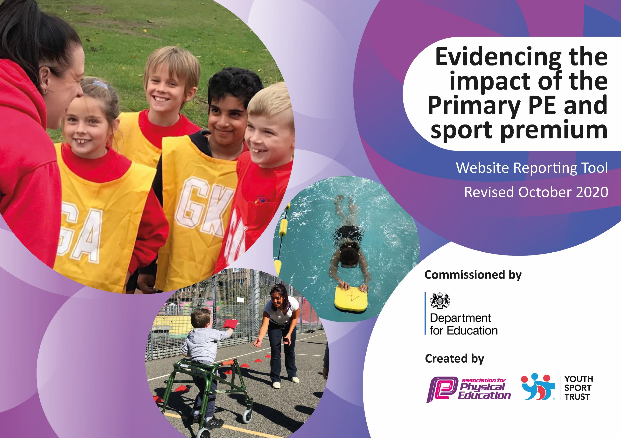
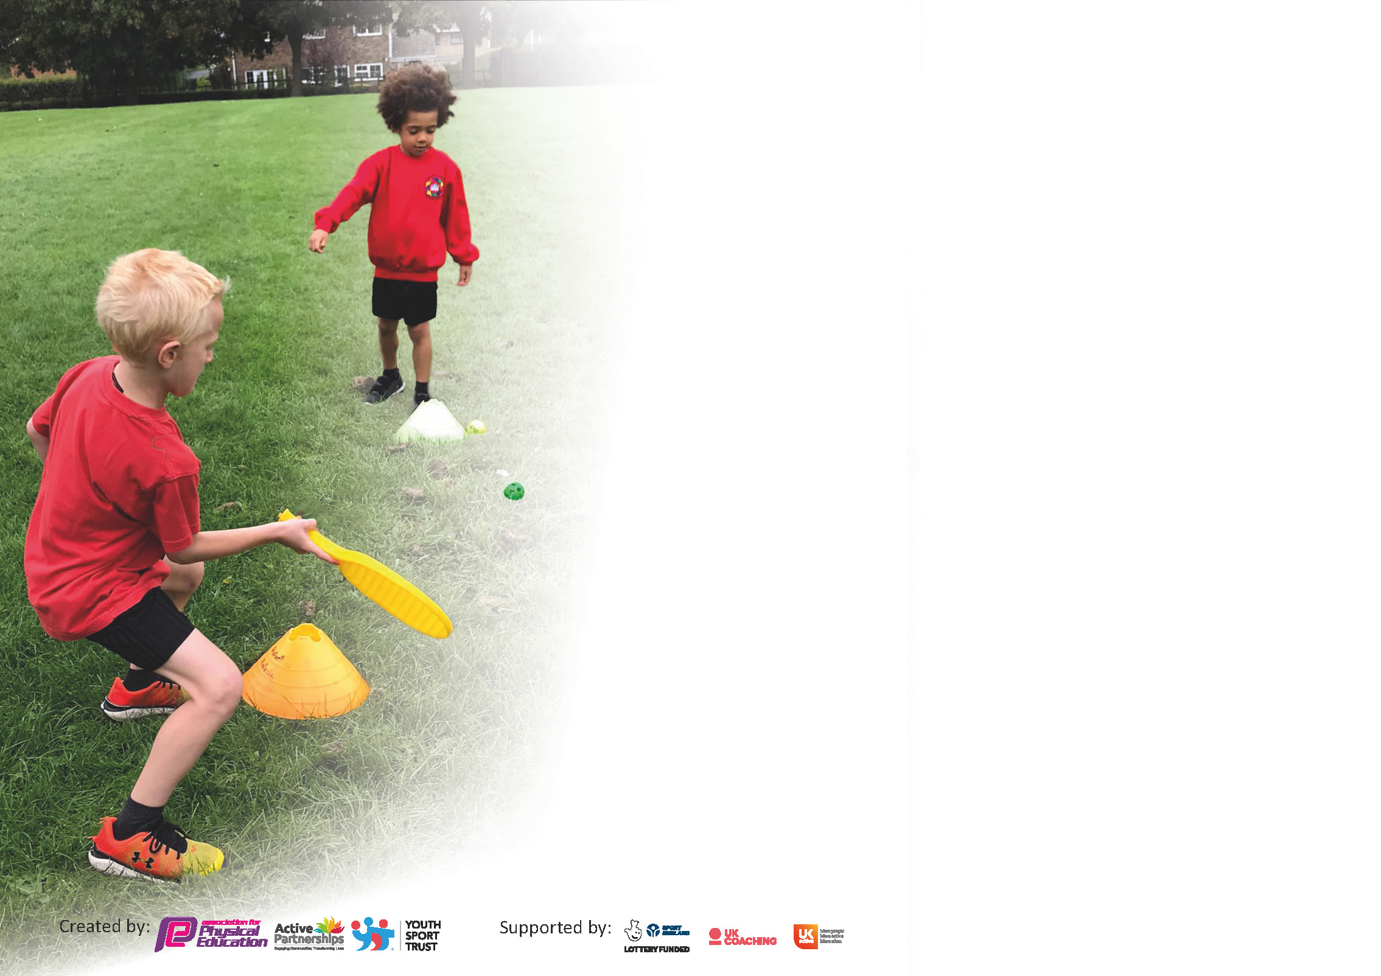

It is important that your grant is used effectively and based on school need. The Education Inspection Framework (Ofsted 2019 p64) makes clear there will be a focus on ‘whether leaders and those responsible for governors all understand their respective roles and perform these in a way that enhances the effectiveness of the school’.

Under the Quality of Education criteria (p41) inspectors consider the extent to which schools can articulate their curriculum (INTENT), construct their curriculum (IMPLEMENTATION) and demonstrate the outcomes which result (IMPACT).

To assist schools with common transferable language this template has been developed to utilise the same three headings which should make your plans easily transferable between working documents.

Schools must use the funding to make additional and sustainable improvements to the quality of Physical Education, School Sport and Physical Activity (PESSPA) they offer. This means that you should use
the Primary PE and sport premium to:

- Develop or add to the PESSPA activities that your school already offer
- Build capacity and capability within the school to ensure that improvements made now will benefit pupils joining the school in future years

Please visit gov.uk for the revised DfE guidance including the 5 key indicators across which schools should demonstrate an improvement. This document will help you to review your
provision and to report your spend. DfE encourages schools to use this template as an effective way of meeting the reporting requirements of the Primary PE and sport premium.

We recommend you start by reflecting on the impact of current provision and reviewing the previous spend.

Schools are required to publish details of how they spend this funding as well as on the impact it has on pupils’ PE and sport participation and attainment by the end of the summer term or by 31st July 2021 at the latest.

** In the case of any under-spend from 2019/20 which has been carried over this must be used and published by 31st March 2021.

We recommend regularly updating the table and publishing it on your website throughout the year. This evidences your ongoing self-evaluation of how you are using the funding to secure maximum, sustainable impact. Final copy must
be posted on your website by the end of the academic year and no later than the 31st July 2021. To see an example of how to complete the table please click HERE.
Created by: Supported by:

Please note: Although there has been considerable disruption in 2020 it is important that you publish details on your website of how you spend the funding - this is a legal requirement.
Support for review and reflection - considering the 5 key indicators from DfE, what development needs are a priority for your setting and your pupils now and why? Use the space below to reflect on previous spend and key achievements and areas for development.

N.B. In this section you should refer to any adjustments you might have made due to Covid-19 and how these will influence further improvement.
Key achievements to date until July 2020: | Areas for further improvement and baseline evidence of need:
- Construction of the daily mile track allowing all children within the academy to complete at least 30 active minutes of learning outside of PE lessons.  - All children within the academy have taken part in a ‘Race to Tokyo’ running at least one mile per week since spring term cumulatively amassing enough miles to reach Tokyo. Children have been updated weekly on their progress and which country they have reached.  - Resurfacing of MUGAs which have provided various sports opportunities regardless of the weather.  - Provided opportunities for all children to access 30 active minutes outside of PE lessons.  - The engagement of all pupils in regular physical activity kick-starting healthy active lifestyles. I.e. daily mile.  - The profile of PE and sport being raised across the school as a tool for whole school improvement. | - To further develop the opportunities for the pupils to work with professional coaches throughout the year. Resulting in a broader skills set for all pupils across a range of sports.  - To ensure that the consistency of high quality sport and PE sessions are evidenced across the school by releasing the sports lead to work with coaches and the partnership staff to support staff who are less confident at delivering certain sports/lessons.

Did you carry forward an underspend from 2019-20 academic year into the current academic year? YES
If any funding from the academic year 2019/20 has been carried over you MUST complete the following section. Any carried over funding MUST be spent by 31 March 2021.
Academic Year: September 2020 to March 2021 | Total fund carried over: £6800 | Date Updated: March 2021
Key indicator 1: The engagement of all pupils in regular physical activity – Chief Medical Officers guidelines recommend that primary school pupils undertake at least 30 minutes of physical activity a day in school |  |  |  | Total Carry Over Funding:
 |  |  |  | £6800
Intent | Implementation |  | Impact
- Part funded - Construct a ‘Daily Mile’ track in the school grounds.  - Part-funded - Re-surface the two existing MUGAs. | - Promote a ‘daily mile’ throughout the academy for all children to complete. Once established, leader boards and competitions between both within the academy and across academy chains to promote fitness and wellbeing. | - Carry over funding allocated: £6800 | - Both projects will enhance and give greater opportunities for all children in the academy to undertake a minimum of 30 minutes physical activity a day in school. | - Competitions. Sports day

Meeting national curriculum requirements for swimming and water safety.

N.B Complete this section to your best ability. For example you might have practised safe self-rescue techniques on dry land.
What percentage of your current Year 6 cohort swim competently, confidently and proficiently over a distance of at least 25 metres?  N.B. Even though your pupils may swim in another year please report on their attainment on leaving primary school at the end of the summer term 2021. | 84%
What percentage of your current Year 6 cohort use a range of strokes effectively [for example, front crawl, backstroke and breaststroke]? | 68%
What percentage of your current Year 6 cohort perform safe self-rescue in different water-based situations? | 64%
Schools can choose to use the Primary PE and sport premium to provide additional provision for swimming but this must be for activity over and above the national curriculum requirements. Have you used it in this way? | No

Action Plan and Budget Tracking
Capture your intended annual spend against the 5 key indicators. Clarify the success criteria and evidence of impact that you intend to measure to evaluate for pupils today and for the future.

Academic Year: 2020/21 | Total fund allocated: £18, 820 | Date Updated: 5.4.21
Key indicator 1: The engagement of all pupils in regular physical activity – Chief Medical Officers guidelines recommend that primary school pupils undertake at least 30 minutes of physical activity a day in school |  |  |  | Percentage of total allocation:
 |  |  |  | 55%
Intent | Implementation |  | Impact
Your school focus should be clear what you want the pupils to know and be able to do and about  what they need to learn and to  consolidate through practice: | Make sure your actions to achieve are linked to your intentions: | Funding allocated: | Evidence of impact: what do pupils now know and what can they now do? What has changed?: | Sustainability and suggested next steps:
- Part funded - Construct a ‘Daily Mile’ track in the school grounds so children can complete the ‘daily mile’ in all weathers throughout the year. To aid daily activity levels and provide sustainable use of the funding moving forward.  - Part-funded - Re-surface the two existing MUGAs to enable a variety of invasion games to be taught during PE sessions with the added benefit of being used throughout the year during children's break and lunch times. | - Promote a ‘daily mile’ throughout the academy for all children to complete. Once established, leader boards and competitions between both the academy and across academy chains to promote fitness and wellbeing. | £5390 | - Both projects will enhance and give greater opportunities for all children in the academy to undertake a minimum of 30 minutes physical activity a day in school. | - Competitions  - Sports day
- Increased participation in sport | - Events throughout the year to promote physical activity | - £300 | - Children participate in a range of sports for all age ranges across the academy. To include both competitive and team opportunities.
- To purchase equipment to ensure children are physically active and engaged during break times and lunch times including a portable music system and two interactive wall games (ActivAll). | - Children are physically active and engaged during break times and lunch times.  - Equipment audit and replacement.  - Lunchtime staff provided with demonstration lessons of how to use equipment effectively and safely.  - Purchase outdoor equipment for pupils to use during break and lunch times. | - £4600 | - New playground equipment will ensure children are active for at least 30 minutes a day. Help to develop sporting and social skills when participating in activities. | - Purchase new equipment for the playground. In light of COVID-19 and full opening guidance from DFE, each bubble will have their own equipment.  - Equipment managed and cleaned by each year group. Assign sports leaders/lunchtime staff to manage and demonstrate how to use equipment effectively.
Key indicator 2: The profile of PESSPA being raised across the school as a tool for whole school improvement |  |  |  | Percentage of total allocation:
 |  |  |  | 8%
Intent | Implementation |  | Impact
Your school focus should be clear what you want the pupils to know and be able to do and about  what they need to learn and to  consolidate through practice: | Make sure your actions to achieve are linked to your intentions: | Funding allocated: | Evidence of impact: what do pupils now know and what can they now do? What has changed?: | Sustainability and suggested next steps:
- Take part in inter-school competitions across the area through the Middlesbrough Schools Sports Partnership.  - Use PE and sport to enable the development of life skills that are transferred to other curriculum areas, wider school and beyond.  - Use PE and sport to develop the whole person including thinking, social and personal skills. | - As a school we contribute funding to sustain the Middlesbrough School Sport Partnership which provides the following opportunities:  - Additional competitions outside of the School Games programme  - Comprehensive CPD programme  - PE Conference  - Outdoor activity days  - Primary Leadership Academy  - Sports Awards  - Support from Andy Oliver | - £1000 | - More children interested and taking part in competitive sport.  - A range of events will be held by Tees Valley Education across linked academies and at various venues. Successful academies will be presented with awards to celebrate the children’s success.  - Personal development (physical skills, thinking skills, social skills and personal skills).  - Attainment and achievement, behaviour and attendance.  - PE physical activity and school sport have a high profile and are celebrated across the life of the school  - SMSC - Children learn to respect and work with each other, exercise self-discipline and act in a safe and sensible manner.  - Pupil interviews inform us that pupils enjoy their PE lessons and that pupils enjoy the variety of activities on offer during curriculum PE.  - Interhouse competitions raise profile of competitive sport within school. As many children as possible to participate.  - Sports leaders impact importance of sport/activity by being positive role models in the school | - Continued participation in Middlesbrough Schools Sports Partnership.  - Staff are more confident at delivering training/P.E sessions for children who excel in sport.  - School staff better equipped/more confident to teach PE in school  - Monitoring use of schemes and whole school PE coverage  - Sports leaders develop younger pupils into becoming leaders themselves
- Pupils have opportunities to learn to lead during PE & sporting activities.  - Children to have greater experience and confidence in leading others | - YL to assist in running Sports Day and lunchtime activities (as COVID19 protocol allows.)  - Pupils to lead warm up and activities during curriculum PE lessons.  - Use of more able pupils to officiate game play. | - £100 | - KS2 pupils all involved in leading during academic year.  - Rotas.  - Pupil feedback.  - Staff feedback on confidence & self-esteem in pupils.
- Improve reviewing and assessment of PE by pupils, using self & peer assessment tools. | - Purchase a dedicated PE IPad to be used in lessons for recording, reviewing and assessing activities by all pupils.  - Improve peer and self-assessment techniques throughout school with technology | - £450 | - Pupils become more confident in reviewing their own and others work.  - Improved pupil feedback.  - Higher % of pupils achieving EXP/GDS

Key indicator 3: Increased confidence, knowledge and skills of all staff in teaching PE and sport |  |  |  | Percentage of total allocation:
 |  |  |  | 16%
Intent | Implementation |  | Impact
Your school focus should be clear | Make sure your actions to | Funding | Evidence of impact: what do | Sustainability and suggested
what you want the pupils to know | achieve are linked to your | allocated: | pupils now know and what | next steps:
and be able to do and about | intentions: |  | can they now do? What has
what they need to learn and to |  |  | changed?:
consolidate through practice:
- To continue upskilling staff in the academy to improve progress and achievement within PE.  - Raise the quality of learning and teaching in PE and school sport by providing support to deliver broad, balanced and inclusive high quality PE and school sport provision (within and beyond the curriculum) to raise pupils’ attainment. | - Target teaching of PE in areas in which staff are less confident. Embed HQ principles. Training sessions as requested by staff including resources available.  - Use specialist coaches and providers for staff training to increase the knowledge and confidence of staff in delivering PE.  - Purchase quality assured resources to support teachers and support staff.  - PE lead/sports coaches used to help upskill teachers through modelling lessons, team teaching, help with planning and observations. Classes rotated to ensure all teachers benefit from coaches expertise (KS1 = skills focus, KS2 = sport specific focus)  - Subject Leader to attend relevant sport conferences and network meetings to gain relevant information.  - Liaise with other local schools to share knowledge and expertise. | - £3000 | - Increased staff knowledge and understanding  - All teachers able to more confidently plan, teach and assess National Curriculum PE  - More confident and competent staff evidenced through feedback and lesson observations  - More sustainable workforce including young leaders.  - Enhanced quality of provision  - Increased pupil participation in competitive activities and festivals  - Increased range of opportunities  - A more inclusive curriculum which inspires and engages all pupils  - Increased capacity and sustainability  - Continued progression of all pupils during curriculum PE lessons.  - Questionnaires/interviews inform us that pupils enjoy their PE lessons  - Discussions inform us that pupils enjoy the variety of activities on offer during curriculum PE. | - Review staff confidence and competence in delivering high quality PE and school sport and allocate staff to upcoming CPD opportunities  - Further 1:1 lesson observations to monitor staff effectiveness and confidence  - Higher expectations in a range of activities are being developed, which in turn will mean higher quality lessons, building future sustainability. - Review staff confidence and competence in delivering high quality PE and school sport and allocate staff to upcoming CPD opportunities
Key indicator 4: Broader experience of a range of sports and activities offered to all pupils |  |  |  | Percentage of total allocation:
 |  |  |  | 9%
Intent | Implementation |  | Impact
Your school focus should be clear | Make sure your actions to | Funding | Evidence of impact: what do | Sustainability and suggested
what you want the pupils to know | achieve are linked to your | allocated: | pupils now know and what | next steps:
and be able to do and about | intentions: |  | can they now do? What has
what they need to learn and to |  |  | changed?:
consolidate through practice:
- Half-term clubs/Easter and summer clubs led by external sports coach. | - Cost of sports coach for two days in each holiday. | - £1450 | - Pupils and parents know how to access local sports opportunities.  - Children get to try out local community clubs by attending their sessions, or clubs coming into BPA.  - Teachers have knowledge of clubs available to sign post pupils. | Strong links are made with local sports clubs and community funding agencies in order for our children to access a wider range of sports and activities.
- More after school clubs from outside agencies to target less active children.  - Rewards for children across the academy | - Local after school clubs to be invited to the academy to support provision and range of sports on offer.  - E.g. Y6 to visit clip and climb | - £300 | - Children’s enjoyment at trying something new, which may to lead continued participation in activity. | Ensure that learning assistants have the necessary CPD to ensure that wider range of extra-curricular sports actives can be offered.
- Deliver a range of learning opportunities using Sports premium funding both within curriculum PE and as extra- curricular clubs.  - Continue to raise profile of activities during National School Sports Week.  - Evaluate activities available for pupils who do not usually take part an extracurricular club.  - Pupils experience sports they have not known of before. | - All actions to be reviewed in line with Government COVID19 protocols & may not be possible in 2020-21 so currently no costing provision has been made.  - Coordinate a range of learning opportunities both in curriculum time & after school clubs which enhance our current PE provision.  - Increase the number of sports activities that they offer to their pupils.  - Increase the % of pupils taking part in 2+ and 3+ hours of PE and Sport each week. |  | - Higher percentage of children attaining EXP and GDS.  - All pupils from KS1 & 2 attending an extra-curricular club. (If possible due to COVID19 risk assessments.)  - Registers. Participation data.  - New sports investigated.  - Clubs run only if safe in line with Government protocols.  - Pupils continue to attend a range of after school clubs in 2021-22. | Following the lifting of government restrictions it is hoped that wider range of sports can be delivered within the academy by external stakeholders

Key indicator 5: Increased participation in competitive sport |  |  |  | Percentage of total allocation:
 |  |  |  | 12%
Intent | Implementation |  | Impact
Your school focus should be clear | Make sure your actions to | Funding | Evidence of impact: what do | Sustainability and suggested
what you want the pupils to know | achieve are linked to your | allocated: | pupils now know and what | next steps:
and be able to do and about | intentions: |  | can they now do? What has
what they need to learn and to |  |  | changed?:
consolidate through practice:
- To promote sport through a world event (Olympics 2021). To promote the spirit of the games as a whole school initiative. | - Planned for the Spring/Summer term - a week long programme of activities: assemblies, demonstrations, and physical activities. Cross-curricular links with science geography, history etc. | - £2000 | - Annual promotion and awareness raising of the core values of “The Spirit of the Games” All children will take part in a daily programme of sport wellbeing and healthy eating activities. Sports leaders to help plan and deliver programme of events which promote and raise awareness of the core values  - Hire of assault courses and equipment for Olympics day. | To have an annual Olympics within school offering a full range of sporting activities so that all children can achieve
- Increase the % of pupils taking part in inter-school competition by attending cluster virtual sporting events – Spring/Summer | - Attend virtual cluster sporting opportunities for all pupils (fully inclusive) 2020 -21  - Deliver an inclusive sports day 2021 linked to Tokyo 2020.  - Ensure competitive opportunities are embedded in curriculum PE.  - Consider more intra competitions – KS2 competitive lunchtime matches.(Covid-19 permitting)  - Increased number of Intra matches to take place in curriculum PE. | - £230 | - % of pupils who have taken part in Inter School Competition.  - % of pupils who have taken part in virtual School Competition.  - Registers.  - Number of competition entries from school.  - Subject leader reviews/evaluations  - Medals

Signed off by
Head Teacher: | Karen Gleave
Date: | 28/07/2021
Subject Leader: | Shane Swales
Date: | 28/07/2021

